**A COMMUNITY SERVICE PROJECT REPORT ON**

**WOMEN EDUCATION**

**Submitted in partial fulfillment for the award of the degree of**

**BACHELOR OF TECHNOLOGY**

**IN**

**COMPUTER SCIENCE AND ENGINEERING**

**BY**

**SOMA AMRUTHA VARSHINI**

**23A85A0518**

**Under the Esteemed Supervision of**

**Dr.D.Jaya Kumari,**

**Professor Head of the Department**

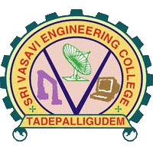

**Department of computer science and Engineering (Accredited by N.B.A)**

**SRI VASAVI ENGINEERING COLLEGE (Autonomous)**

**(Affiliated to JNTUK, Kakinada)Pedatadepalli, Tadepalligudem-534101, AP**

**2023-26**

**SRI VASAVI ENGINEERING COLLEGE**

**(Autonomous)**

**Department of Computer Science and Engineering**

**Pedatadepalli, Tadepalligudem**



­­­­­

**This is to certify that the Community Service Project Report entitled “WOMEN EDUCATION” survey done in Pedatadepalli village, submitted by SOMA AMRUTHA VARSHINI (23A85A0518), for the award of the degree of Bachelor of Technology in the Department of Computer Science and Engineering during the academic year 2022-2023.**

**Name of the Project guide Head of the Department**

**Dr.D.Jaya Kumari, Dr.D.Jaya Kumari,**

**Professor & HOD Professor & HOD**

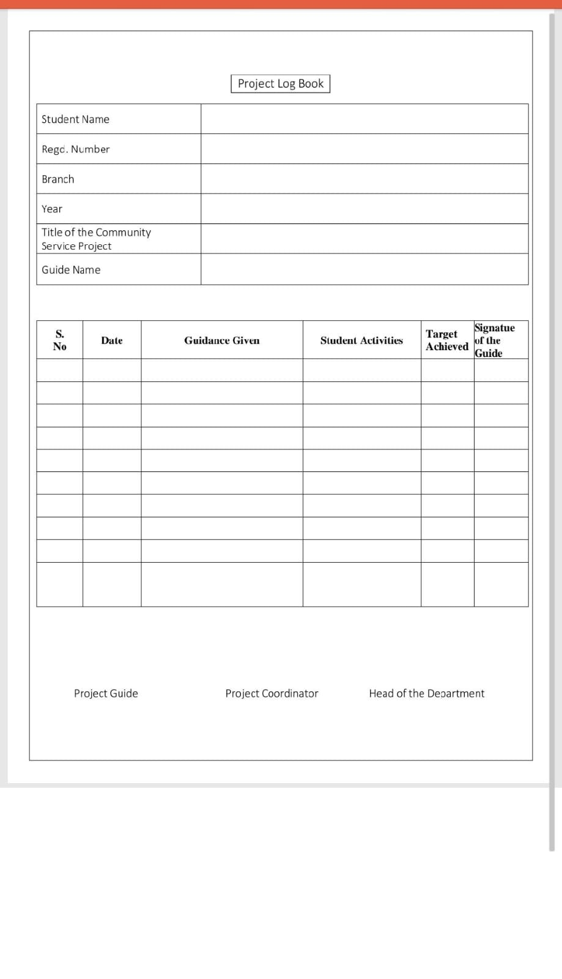

**ACKNOWLEDGEMENT**

**First and foremost, we sincerely salute to our esteemed institute SRI VASAVIENGINEERING COLLEGE, for giving us this golden opportunity to fulfill our warm dream to become an engineer. Our sincere gratitude to our project guide Dr. D. Jaya Kumari, M.Tech, Ph.d, Professor & Head of the Department of Computer Science and Engineering, for his timely cooperation and valuable suggestions while carrying out this project.**

**We express our sincere thanks and heart full gratitude to Dr. D. Jaya Kumari , M. Tech, Ph. d, Professor & Head of the Department of Computer Science and Engineering, for permitting us to do our project. We express our sincere thanks and heart full gratitude to Dr. G.V.N.S.R. Ratnakara Rao, Principal, for providing a favorable environment and supporting us during the development of this project.**

**Our special thanks to the management and all the teaching and non-teaching staff members, Department of Computer Science and Engineering, for their support and cooperation in various ways during our project work. It is our pleasure to acknowledge the help of all those respected individuals.**

**We would like to express our gratitude to our parents, friends who helped to complete this project.**

**Amrutha Varshini**

**(23A85A0518)**

**SRI VASAVI ENGINEERING COLLEGE**

**(Autonomous)**

**Department of Computer Science and Engineering**

**Pedatadepalli, Tadepalligudem**

**(2022-2023)**

**Community Service Project for the UG Program**

**WOMEN EDUCATION**

**Name of the Student: SOMA AMRUTHA VARSHINI**

**Regd No: 23A85A50518**

**Branch: CSE**

**Semester: III**

**Topic: WOMEN EDUCATION**

**Area: Dakaram village, Mudinepalli (madalam)**

**Project Guide: Dr. D. Jaya Kumari, Professor & HOD**

**(Student) (Project Guide)**

**Dr. D. Jaya Kumari,**

**Professor & HOD**

**CONTENTS**

1. **Introduction**
2. **Awareness Activities with photos**
3. **Conclusion**

**INTRODUCTION**

**Women play a very important role in the progress of a family, society and country. In order to make democracy successful in the country women education is necessary together with the men. Educated women are the real source of happiness in the family. Education is one of the milestones for women empowerment because it enables them to respond to the challenges, to confront their traditional role and change their life-style.**

**What do we mean by education?**

**>>Education refers to the discipline that is concerned with methods of teaching and learning in schools or school-like environments, as opposed to various nonformal and informal means of socialization**

**>>Education enables children to acquire academic achievements they will need to interpret life situations, develop critical thinking, and make the best possible decisions. Education helps people to better understand social relationships, needs, and behavior of other people.**

**Importance of education?**

**Education provides stability in life, and it's something that no one can ever take away from you. By being well-educated and holding a college degree, you increase your chances for better career opportunities and open up new doors for yourself.**

**We believe that education is the foundation of one's career and but now these days people are using education as a business. They are charging a high fee and also charges for school dress, Bags other fees.**

**Private institute's main Moto is to charge as much they can, They think education is business and people can give a lot of money for their children's education..**

**Due to the increase in the number of institutes competition also increasing and fees also increasing and due to the lack of good teachers, the quality of education decreases**

**And people also think that more fees mean good education but it is not like that.**

**Nowadays, Most of the legends came across basically from Government schools.**

**WOMEN EDUCATION IN INDIA**

**>>Education in India Women education in India plays a very important role in the overall development of the country. It is not only helps in the development of half of the human resources, but in improving the quality of life at home and outside (Suguna, 2011). The Indian Education system has two important structures, one is formal and another one is non-formal education. Some other educational programmes also formulated to motivate the women education such as online education and distance education**

**>>On these, 17.9 million are boys and 15.4 million are girls as of 2014-2015. Fundamental Rights of women are equality, freedom to religion, educational rights, cultural and educational, against exploitation, freedom. Improving girls' educational levels has been demonstrated to have clear impacts on the health and economic future of young women, which in turn improves the prospects of their entire community. After the Universal Declaration of Human Rights**

**>> Women education is an essential need to change their status in the society. Educated women can play a very important role in the society for socio-economic development. Education eliminates inequalities and disparities as the means of recovering their status within and out of their families. It is the key factor for women empowerment, prosperity, development and welfare. Education provides more strength to women. Such strength comes from the process of empowerment and empowerment will come from the education. Education plays a significant role in women empowerment inequality and vulnerability of women in the society in India.**

**Steps to improve woman education:**

**It is obvious that the above objectives can only be achieved by, first and foremost, ensuring that women acquire quality education. When this is done, the knowledge, skills, attitudes and other potentials that are required by women for full participation in national development will be developed.**

**Following are the objectives to improve women education:**

**1. Enable women to improve their family health and diet.**

**2. Increase women’s productive ability, thus raising their family’s standard of living.**

**3. Give women access to appropriate technologies and management of cooperatives 4. Improve women’s societal and cultural status.**

**5. Enable women discharge their responsibilities more effectively.**

**6. Help women to fight their own fears and feelings of inadequacy or inferiority**

**7. Educate women in all round development that is mentally, socially, physically, psychologically, religiously.**

**Advantages of woman education:**

**Social improvement:**

**Women education helps the women to solve the issues and problems faced by society. Kothari commission of 1968 recommended education as a device for social progression. Through woman education, India can attain the objective of social development.**

**Gender equality:**

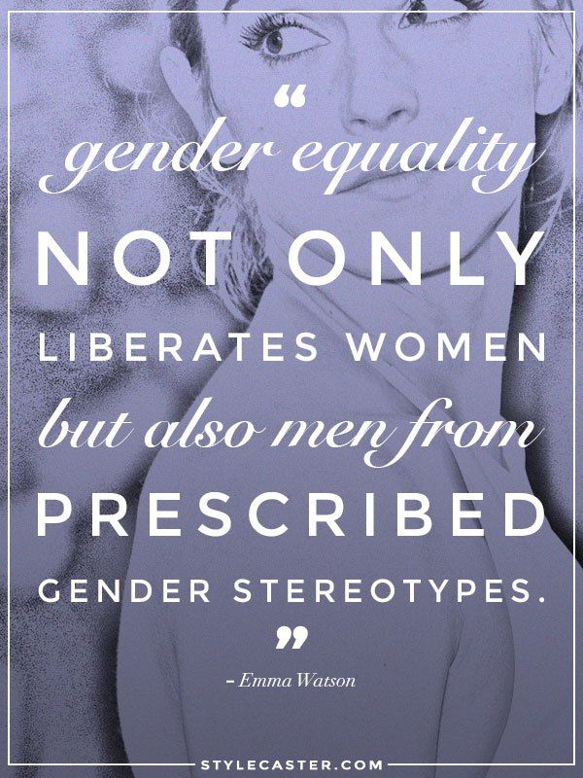

**Woman is a part of unprivileged section of society. Education helps them to seal a gender gap in society. Coeducation institutes also teach men children to give respect to female.**

**Economic productivity:**

**Through women education the country can attain the growth in the economic level and it also raise the GDP of a nation.**

**Decrease in infant humanity:**

**The educated women understand her family situation and take suitable and better decisions in the family to avoid the dispute among the family members. Women education also brings down the infant humanity rate in India.**

**Improved living standard:**

**Education will automatically increase the employment opportunity for a woman. A well educated woman has the possibility to get good job and better standard of living.**

**Strengthening of democracy:**

**Education creates attentiveness among woman which causes enlarged contribution in politics which eventually leads to strengthening of democracy. They could protect their rights through mobilization.**

**Women education in simple words**

**The education of women will help to remove the social stigma that surrounds it. It is the key to eliminating social evils such as female infanticide, dowry, child marriage, harassment, etc. This will not just help the women of today but of the future generations who can live in a world where gender equality exists.**

**Awareness Activities with Photos**

**1.**

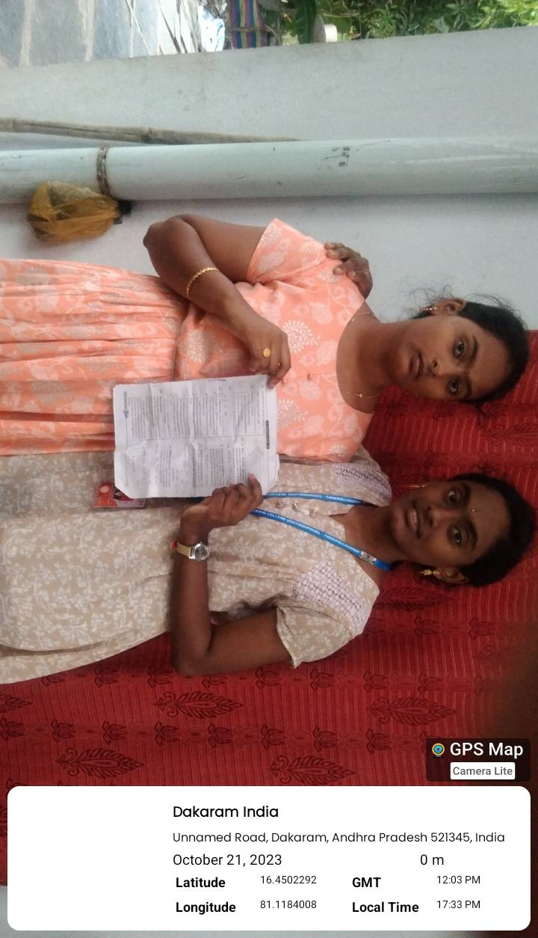

**2.**

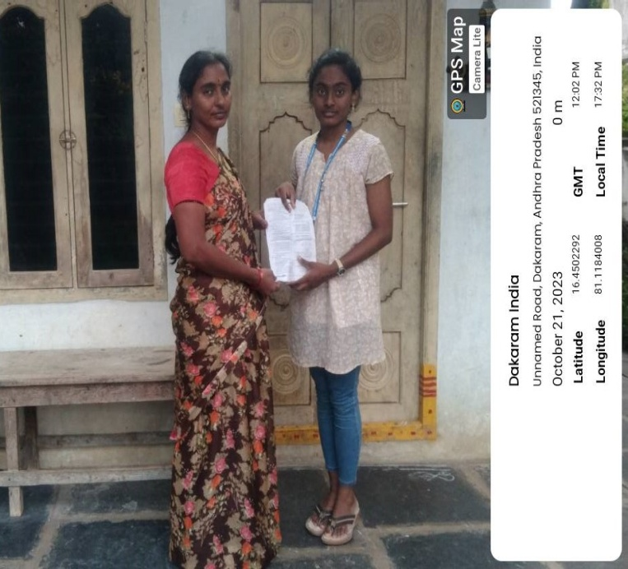

**3.**

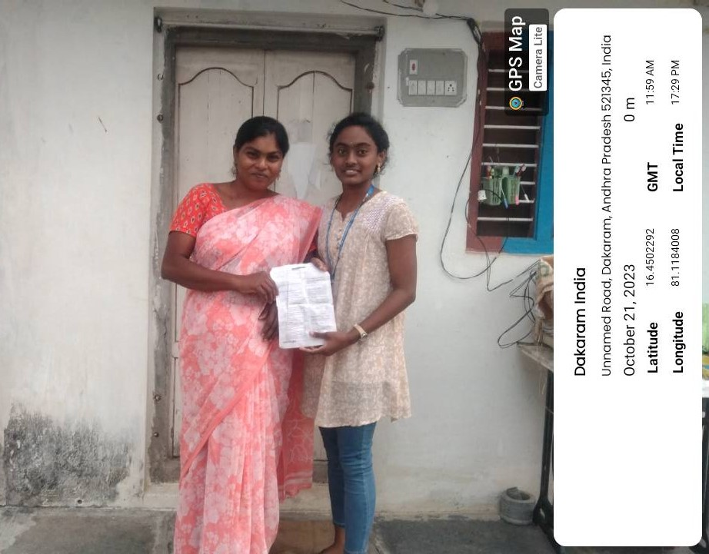

**4.**

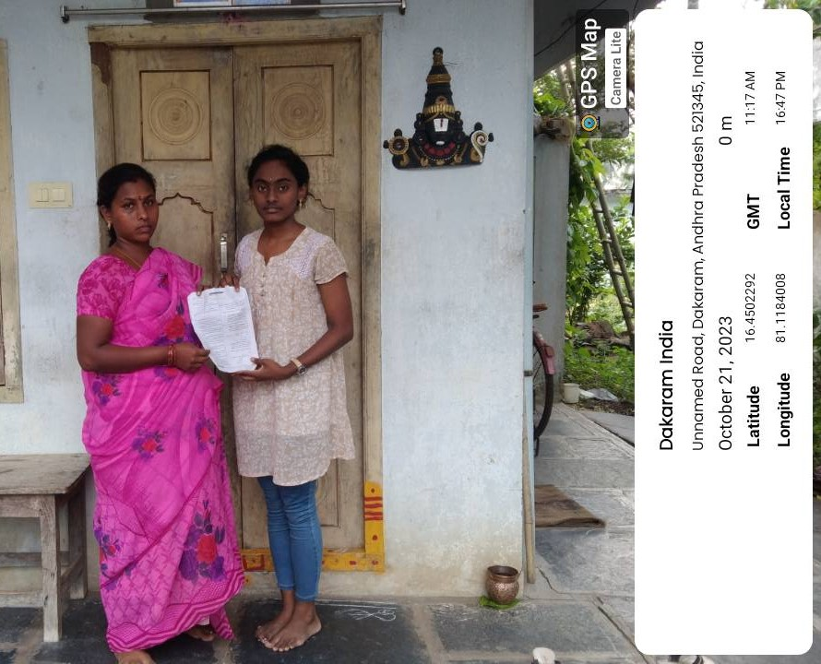

**5.**

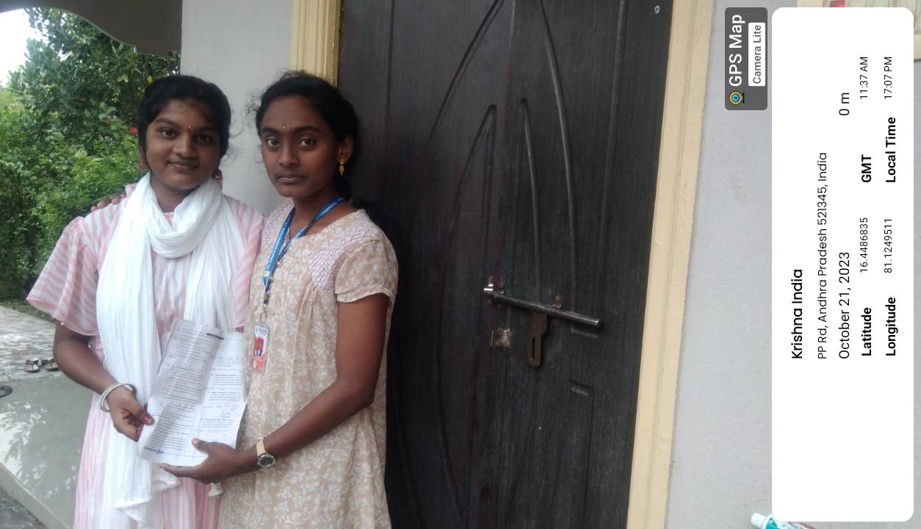

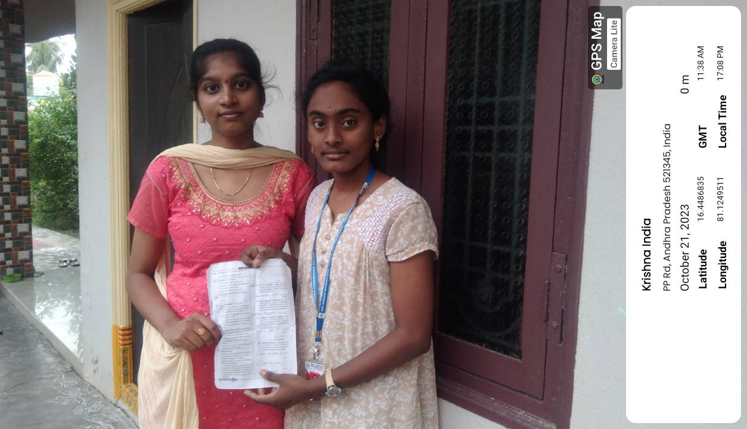

**10 Best Charities for Female Education**

* **Some of the best charities for female education include the Bill & Melinda Gates Foundation, CAMFED, and the Care Foundation. These charities and foundations run educational programs and offer financial help to women in need of support.**

**Below are our favorite charities for female education**

* **Bill & Melinda Gates Foundation**
* **CAMFED**
* **Share & Care**
* **School Girls Unite**
* **Friendship Bridge**
* **Care**
* **Step Up**
* **Malala Fund**

**Women Education - Welfare Schemes**

**India has significantly done well in providing education to the citizens of the nation. The nation's rate is 73.2%, of which 59% of women are literate. The government has established many welfare schemes for motivating women's education in India.**

**The following are a few welfare schemes.**

**• BetiBachao, BetiPadhao**

**The BetiBachao, BetiPadhao social campaign was launched on 22nd January 2015, which is famous for women empowerment. The scheme aims to exterminate female foeticide and access them with an appropriate.**

**• Working Women Hostels**

**The Working Women Hostels scheme was established to provide a working environment that includes accommodation facilities where women may get more employment opportunities.**

**Support Training and Employment Programme**

**These schemes provide adequate education and uplift women to be self-employed or bidding entrepreneurs in various sectors. This scheme is open for women above the age of 16.**

**Mahila- E- Haat**

**• The Mahila scheme was launched in 2016 by the Ministry of Women and Child Development. It provides a platform to let women entrepreneurs or women with small scale businesses display or sell their products and services.**

**• SABLA**

**• Rajiv Gandhi Scheme for Employment of Adolescent Girls (RGSEAG), known as SABLA, initiated on 1st April 2011 by the Government of India. It aims at providing food and nutritious ingredients.**

**• SwadharGreh The SwadharGreh scheme was established in 2002 by the Union Ministry of Women and Child Development. The scheme provides shelter, food, care, and clothing to unaided women. Thus, women abandoned by their families and women who survived during any disaster are aided with basic needs.**

**• One-Stop Centre Scheme**

**The One-stop Centre scheme was established with the 'Nirbhaya' fund on 1st April 2015 by the Ministry of Women and Child Development. The scheme provides counseling services, legal requirements, police aid, shelter and food to violence victims both in public and private.**

**• Nari Shakti Puraskar**

**Nari Shakti Puraskar initiative is taken by the Ministry of Women and Child Development to acknowledge women by awarding them for their excellent contribution towards society and empowering women. Benefits of Women Education If the nation's women were educated, the generation would be educated, leading to the country's development. Moreover, educating women leads to many reforms, a better understanding of concepts. Below are a few benefits from women's education.**

**• If women educate themselves, the nation will undergo a steady population, and family planning would be the priority.**

**• Women's education would make them self-sufficient, and the age of marriage would probably extend, and women would be more independent of their needs and decisions.**

**• Women will be able to refrain from dramatic situations and would look after themselves and their families.**

**• Women can examine themselves in various fields.**

**• Women's education gives power to equality.**

**• Many social discrepancies will be exclaimed, and a powerful system might be established.**

**• Women's education helps women to voice out their opinions.**

**Non-Profit Organizations Promoting Women Education**

**Various organizations promote and work for promoting women education in India.**

**These organizations fight against emphasizing the importance of women education in India and gender equality.**

**Some of the non-profit organizations that promote women education are**

1. **Educate Girls Bond: It creates new opportunities for girl's education and promotes gender equality by providing education for young girls throughout India.**

**2. Global Grassroots: The organization promotes leadership in women and girls in their communities by employing mindfulness throughout designing a social solution .**

**3. Pratham: It is designed to improve education for children in Mumbai.**

**4. Campaign for Female Education (CAMFED): It is an international non-profit organization supporting marginalized girls to succeed through education.**

**5. Girls Who Code: An international organization aiming to provide opportunities for women to learn and develop specialized skills in computer science.**

**Influential Women in Education Field**

**Women are considered the nation's building block; empowering women is similar to empowering a nation. Indian Women have remarked their country's name and made us proud in every aspect.**

**Below are the influential women in India.**

**• Avani Chaturvedi - She is the first Indian woman fighter pilot to fly MiG-21 Bison and is all set to fly.**

**• Manika Batra - Top-ranked female table tennis player from India, she holds 47th rank in the world.**

**• Gita Gopinath - She is the first Indian female appointed as chief economist at the International Monetary Fund (IMF).**

**• Hima Das - is the first Indian Women Athlete who won gold at the IAAF World Under 20 Athletics Championships.**

**• Chungneijang Mary KomHmangte - She is the only woman who grabbed the World Amateur Boxing Champion's title. She had won medals in all seven world championships.**

**• Padmasree Warrior - The former Cisco CTO made it to America's top Women in Tech published in Forbes'.**

**• Seema Rao is India's first women commando trainer, also known as India's Wonder Woman.**

**• KomalMangtani is the world's most influential female software engineer who heads the Business Intelligence Team at Uber.**

**A nation's well-being is defined if the women are strong and capable of withstanding any storm. We preach women by the names of goddesses. We bow down in front of them to achieve success. They are the individuals who rule the world, and we need to treat them with the utmost dignity in all spheres of life to build the most influential and prominent country. The new strategies and initiatives like socio-cultural practices promote women's education by introducing social empowerment tools with access to education, health care, and access to equal opportunities legally.**

**Benefits of Women Education**

**If the nation's women were educated, the generation would be educated, leading to the country's development. Moreover, educating women leads to many reforms, a better understanding of concepts. Below are a few benefits from women's education.**

**• If women educate themselves, the nation will undergo a steady population, and family planning would be the priority**

**• Women's education would make them self-sufficient, and the age of marriage would probably extend, and women would be more independent of their needs and decisions.**

**• Women will be able to refrain from dramatic situations and would.**

**• Women will be able to refrain from dramatic situations and would look after themselves and their families.**

* **Women can examine themselves in various fields.**

**• Women's education gives power to equality .**

**• Many social discrepancies will be exclaimed, and a powerful system might be established.**

**• Women's education helps women to voice out their opinions.**

**Non-Profit Organizations Promoting Women Education**

**Various organizations promote and work for promoting women education in India. These organizations fight against emphasizing the importance of women education in India and gender equality.**

**9 states with highest female Literacy Rate:-**

**Kerala:-** **Kerala has been the most literate state in India with a total literacy rate of 95.2%. The women literacy rate is 92.1% whereas male literacy is 96.1%.**

**Mizoram:- ands at second spot having the female literacy rate of 89.3%. With total of 91.3% literacy rate and male literacy of 93.3%.**

**Tripura:- Tripura’s female literacy rate is 82.7% with a total literacy rate of 87.2%. The male population literacy is 91.5%.**

**Nagaland:-The female literacy rate of Nagaland, the mountainous state is 76.1%.The male literacy is 82.8% with total of 79.6% literacy rate.**

**Himachal Pradesh:- Himachal with mighty Himalayas is at 6th spot with 75.9% of female literacy rate and male literacy rate of 89.5%. The total literacy rate is 82.8%.**

**Maharashtra:- AA16 L The second most populated place in India has 75.9% women literacy rate. A total of 82.3% literacy rate and 88.4% male literacy.**

**Tamil Nadu: -Famous for its temple has 73.4% of female literates and male literacy of 86.8%. The total literacy rate is 80.1%.**

**Sikkim:- Sikkim has female literacy of 75.6%. The current literacy rate is 81.4 and male literacy rate of 86.6%.**

**Manipur:- Manipur called the jewel of India with the female literacy rate of 72.4% and total of 79.2% literacy rate. The male literacy rate is 86.1%. The gap between the literacy rates of males and females remain grave. Many girls drop out of schools due to financial support. The launch of many female literacy campaigns may help in filling the gender gap in coming years.**

**What are the steps taken by the government to empower women?**

**SWADHAR Greh, one of the Government schemes for women's empowerment in India, aims to provide shelter, food, clothing, social, economic and health security. This scheme provides legal assistance to women and helps them take initiative for readjusting in societies.**

**WOMENARE THE REAL ARCHITECTS OFSOCIETY**

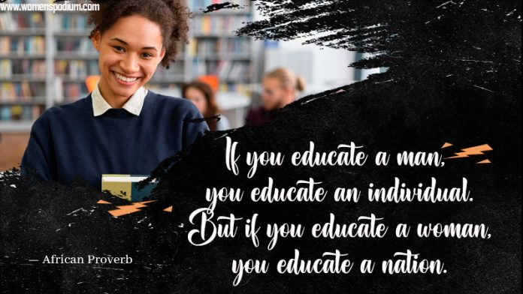

**Malala Yousafzai – Nobel Peace Prize winner**

**This 23-year old activist has a long history of advocating for the rights of girls to education. When she was just 11, she wrote an anonymous blog about life in a Taliban-controlled region for BBC Urdu. The following year, she was the subject of a documentary, Class Dismissed, about the schools closed down by the Taliban. Malala made headlines around the world in 2012, when she was the victim of an assassination attempt by a Taliban gunman in retaliation for her public activism. She recovered and continued her work raising awareness of the importance of education for children around the world.**

**In 2014, she was awarded the Nobel Peace prize for her activism, becoming the youngest Nobel laureate in history. Nowadays she is studying philosophy, politics and economics at Oxford University, and recently published We Are Displaced, a book about the lives of refugee girls around the world, using her platform to share other girls’ stories.**

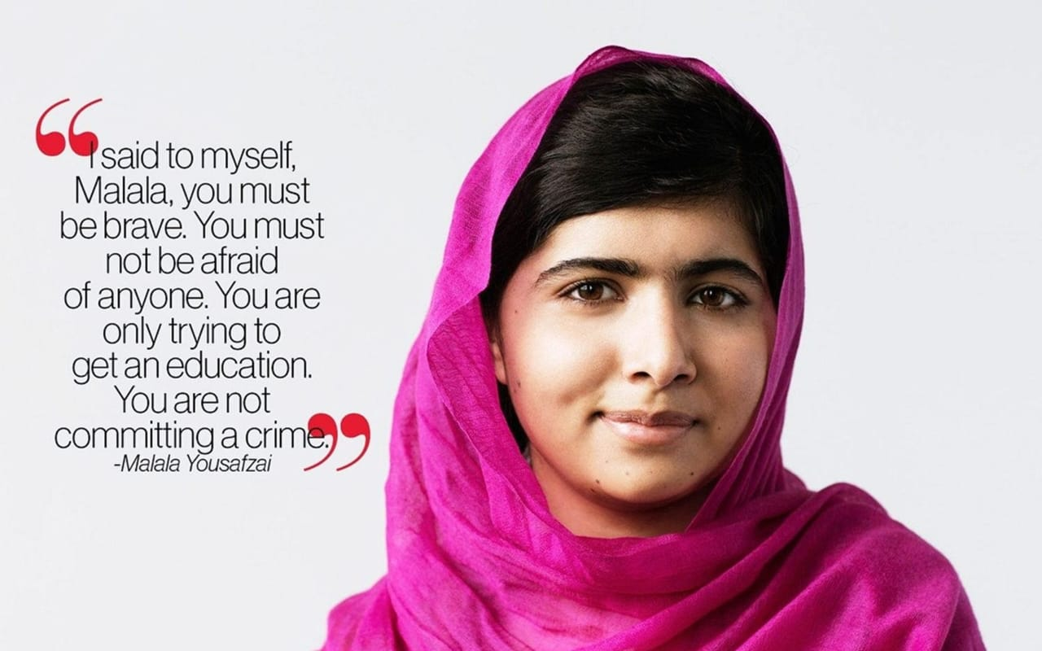

**Most Inspiring Women in the Education Field in India**

**“A society, the world, and the very existence is incomplete without women. Females are natural creators, who share a sense of inclusivity which the world invariably longs for.” India has a number of inspiring women ever since the time of independence. Even before that. Women have fiercely and gently shaped society with their warmth and understanding. The above statement may look paradoxical; however, that is the reality. Women are capable of logically and creatively shaping society.**

**It is essential to understand the background of India. It has been a patriarchal society. Also, India being a developing nation, has its grassroots problems. So in such a scenario, simple comforts were a far-fetched goal for women in the country. Education is a distant dream for many. However, time always changes. Those who live for a purpose find a way as well. So have been many notable women in India. The article given below takes an in-depth dig AA21 L into the lives of these wondrous women who made huge by defeating all odds. Scroll down below to know in detail about the 20 Most Inspiring Women in Education Field.**

**List of the 20 Most Inspiring Women in Education Field**

**Indeed, the number of phenomenal women who have made their contribution to uplifting Indian society is endless. So many women work day in and day without any expectations. Many names go unheard. These unsung heroics are slowly transforming the face of the country. So in this article, we bring you the stories of some of them. Surpassing every hurdle, overcoming all the obstacles, here is a list of the top 20 most influential women in India. Check below: –**

1. **Savitribai Phule:-**

**Any article in the field of Women’s Education goes incomplete without the mention of this phenomenal woman, Savitribai Phule. She happens to be India’s first female teacher. It is essential to understand that during the early times, women hardly got access to Education, especially in India. Savitribai Phule fought all odds such as caste system, male dominance, etcetera. At that time, it was unimaginable and impossible for any woman to step up and stand for a cause. However, Savitribai Phule broke all the chains and strove for the Education of women in India. She didn’t do it in words but in action. She became a living example in herself.**

**With the support of her husband and tireless effort to promote equal education for all, Savitri Phule and her family became a living example breaking various preconceived notions. Her story became a stepping stone for various other girls in India to pursue education. They also started a school for girls and the ‘Native Library’. The idea was to reach out to maximum students across the country.**

**Just one person became the torchbearer for many. They also took the responsibility of a widow’s son and arranged inter-caste marriage for him. This evil still prevails in society. Savtribai Phule set a commendable, impossible example for many lives at that time. Today, Savitribai Phule University Pune has been built after her name. This university carries out the legacy of holistic education.**

**Indeed the whole nation salutes Savitribai Phule for her significant efforts in the field of education and reformation of society.**

1. **Asima Chatterjee:-**

**Another notable woman in the Education field is Asima Chatterjee. She happens to be the first woman to be awarded a Doctor in Science by an Indian University in the year 1944. Not only that, she is the first woman to be elected as the General President of the Indian Science Congress, a premier institute in scientific research. Her primary inclination was towards national products in Medicinal Chemistry. She had been awarded various AA22 L accolades and titles. Some of these awards were- CV Raman Award, PC Ray Award, and the Padma Bhushan Award, and there were many such recognitions.**

**She also contributed her share through her notable work in editing and writing. In the 1940s, she served as HOD of Chemistry subject at Lady Brabourne College, Calcutta. Asima Chatterjee has contributed to various research work. Her invaluable contribution in the field of Chemistry of Natural Products is infinitely valuable. She was elected as the General President of the Indian Science Congress in 1975. She contributed a notable share by becoming an example in herself.**

1. **Meghna Ghai, President of Whistling Woods School:-**

**Cinema has the power to transform masses. It is the most powerful medium of communication in any society. Also looking at the current world, the transformation of the cinematic platform is very much visible. From big screens to OTT, from mainstream drama to education and intellectual genres, films are taking shape in almost all the spheres of life.**

**Realizing this importance, Meghna Ghai is taking strides in improving cinema education in India. It is high time that India is looking for an institute, a community where the future aspirants can evolve and brainstorm to produce value creative films in the future. Meghna Ghai has been born and brought up in such an environment also. She was raised watching her father, Subhash Ghai’s films. So no wonder she profoundly understands the pulse of films.**

**Taking the responsibility to educate the masses, they are now running one of the prominent film schools in India. It was started in the year 2006 and currently has become a dream of thousands of young aspirants who want to study and train in cinema. Students here are exposed to wide-ranging genres, opinions, and viewpoints. It gives them a holistic approach to develop a better understanding of cinema. Meghna Ghai is truly an inspiration for many. She has led a path for thousands of aspiring students in India.**

1. **ChandraprabhaSaikiani:-**

**No wind will be a hurdle when a woman strives with the storm of rage and grit to empower herself. ChandraprabhaSaikiani shares 6. an extraordinary story of how she defeated all the odds and got herself educated no matter what.**

**After receiving her education, she started her endeavor at the age of 13. Truly she touched and uplifted so many lives that India could not imagine at that time. Chandraprabha has received a scholarship to study at Nagaon Mission School. Her significant contribution to Education is still relevant in Assam state. She started AsamPradeshikMahila Samity which is currently running as well. Also, ChandraprabhaSaikiani Centre for Women Studies was opened in 2009 by Tezpur University.**

1. **Vimla Kaul:-**

**She is an example of the great saying, “ Be young at heart and not age.” Vimla Kaul, at the age of 80 years is going all out and providing education to children in a small village Madanpur Khadar, Delhi. For the past 20 years, she has been continuing with this educational endeavor.**

**She closely noticed a lack of commitment and worked in the education field for underprivileged students. Vimla took responsibility on her shoulder and strove to uplift kids in the capital city. The prominent regions being Sarita Vihar. Despite the lack of infrastructure and proper building, Sarita Kaul is unstoppable and continues with excellent work.**

1. **Shukla Bose:-**

**She is a truly modern age example of inspiring women in the Educational field. Bose shares a 2-decade long experience in the corporate industry. However, despite all the lucrative offers and a lavish lifestyle, she felt a need to uplift people’s lives. So she left her job in hospitality and started her endeavour in the “Parikrma Humanity Foundation ” intending to introduce at least one student (living in the family) from each family of Banglore. Bose believes in holistic and dynamic education. Recent reports have stated that students at Parikrama are performing as great as any other prominent schools in the country. Truly Shukla Bose is bridging all the gaps, be it gender disparity, economic disparity or any kind of difference. Today up to 1,600 students are attending Parikrma. Indeed Shukla Bose is an inspiration for all Indians.**

1. **Ramabai Ranade :-**

**Ramabai Ranade was born around 1863. Getting married at the early age of 11 with an educator MG Ranade, Ramabai got encouraged to complete her education. She soon specialized in various subjects and became an active member of PrarthanaSamaj (founded by her husband). She organized various educational programs for women and poor people as well. These people were trained in wide-ranging subjects such as vocation, language, and healthcare. She fought against child marriage. She formed SevaSadan in the later stage of her life. This movement was dedicated to deprived and distressed women.**

1. **Verma Mahadevi :-**

**She is a prominent writer, poet, and educationist in India. She has added unparalleled joy to the childhood of so many people in India. Many would recall the story of a squirrel as a fond memory of their student life. She has widely been known for her contribution in the “Chhayavaad ” movement. She has also been regarded as one of the prominent poets in Hindi Kai Sammelan. Later on, she became the Vice Principal of PrayagMahila Vidyapeeth.**

**Her stories and folklore such as Yama, Neelkanth, Gillu, etcetera are countless notable works that have touched the hearts of many and are alive to date. She also received many awards and accolades during her lifetime. It includes Padma Bhushan, Sahitya Akademi Fellowship, Jnanpith Award, and Padma Bhushan. There is so much when it comes to the acknowledgment and works of Mahadevi Verma. All one knows is she resides in everyone’s heart with the notable work she contributed in her lifetime.**

1. **Durgabai Deshmukh:-**

**She is widely known as Iron Lady. An Indian fighter, social worker, lawyer, and politician, Durgbai Deshmukh was a member of the Constituent Assembly and Planning Commission in India. Born in the state of Andhra Pradesh, Durga was married at an early age when she was 8 years old. However, she left her husband in the pursuit to complete her education. She finished her bachelor’s in BA degree and Masters’s in MA in the 1930s. Despite all odds, the iron lady stood tall and unwavering.**

**She obtained a law degree in 1942. It is important to understand this was the time when India was still under the control of the British Raj. This meant education was a farfetched goal, that too for a woman to complete her studies, it becomes nothing more than a dream. Durgabai Deshmukh continued despite whatever the circumstance was. She fiercely participated in the Non-Cooperation Movement. Durgabai was an ardent follower of Mahatma Gandhi.**

**She propagated Gandhi’s ideas and educated countless women by training them in various skills such as weaving and stitching. She soon relaxed that the shortcomings of a nation were lying in prevalent superstitions, lack of education, and inferior treatment to women. Making their upliftment core of her life, Durgabai strove in that direction throughout her life. She was awarded national and international awards. These included: Paul G Hoffman Award, UNESCO Award (for outstanding work in the field of literacy), Nehru Literacy Award, Padma Vibhushan.**

1. **Roshini Mukherjee:-**

**Do you know the founder of the Exam Fear online platform? Do you know that it is the largest study platform for aspiring students studying from class 6 to class 12, in the various subjects along with NEET preparation? The women behind all this transformation are Roshini Mukherjee. When the world is online, why not harness maximum value online only? This young lady based her education model on these lines only. It, not a hidden fact that so many students struggle with studies in their school days. What fears most of them is not about solving a problem but about fear of study itself. This further leads to anxiety of failing or not being able to fit the standards.**

**Roshini could vividly see all these problems and couldn’t ignore it under the carpet. She, therefore, started her new endeavor of Exam Fear to help kids of various age groups. It seemed a completely different decision for the people around as she left her lucrative IT job and threw herself to pursue her passion for teaching. In her early stages, she simply AA25 L created simple YouTube videos. It provided educational content for free. She would explain difficult concepts in a straightforward approach. Her way of teaching is broad and very conducive. She utilizes a visual approach and visual depiction to explain the study topics. She has made thousands of videos and has reached a number of students. Roshini continues to inspire everyone with her simplistic and inspiring approach.**

**11.Mukti Dagli :-**

**“Lack of vision was not able to stop Mukti’s vision.” At the age of 7, young Mukti lost her vision. However, that did not defeat her. She got herself trained in diploma training for blind students. She pursued her BA degree in arts and passed it with first division. It is often said that struggles bring out polishes one’s life like a diamond. However, for her, the definition of her existence was different as that experience acquainted her to the realities which people otherwise are not. She translated it into her mission and went on to teach blind people, especially women.**

**She started Mukta Seva Kunj. It is a non-profit school for visually impaired women. People here are trained as beauticians, chefs, electrical engineers, etcetera. Her idea of education and learning is not limited to only studies. Her idea is based on true empowerment and social reform. Understanding the grasp of marriage in the system, Mukti Dagli took up that responsibility too. She successfully arranged 164 marriages in the last ten years. She supported the marriage of blind pairs. Truly the nation salutes Mukti Dagli for the contribution she made. She has been an integral medium of the transformation of so many lives in the country. Mukti has been awarded the Padma Shri award. She also received Nari Shakti Puruskar for uplifting women. Her idea was simple and straightforward. She has experienced the crushing realities of life.**

**12.Vasudha Prakash:-**

**She happens to have completed her education in doctorate studies from the USA. She would often base her research on special schooling in India. Understanding the ground reality of education in India, Vasudha Prakash took off her dream a step ahead. She started VExcel Online platform. She has focussed on compulsory and inclusive education. V-Excel strives to empower specially-abled students through art, dance, and music. Vasudha believes in holistic training and therefore, she also imparts skill development in various vocational programs such as cooking, car washing, gardening, planting, and more. She envisions, expanding her endeavor in the next 15 years.**

**13. Radha Goenka:-**

**Modern Times problems call for Modern Day solutions. Radha Goenka is one such social entrepreneur who understands the pulse of the situation and is thriving to make an impact in the Indian education system in her unique way. She has pursued her higher education at Pennsylvania University. Had she wanted, she would have got all the best offers from all around the world. However, the loopholes in her own country could not be ignored by her and so she carved her path.**

**She first noticed that parents spend their money earned from ongoing work and toil inexpensive education of students in private schools in the country. Government schools provide free education on the other hand. Why is there such a difference? One the essential reason is the standard of school, language spoken in school and there are many more. So Radha has just set out to fill this gap only.**

**Her organization has developed a unique curriculum that promotes English language and creative learning. Her organization is an NGO that has partnered with 2000 government schools all across the country. Here the idea is to empower students with creative thinking and independent learning.**

**The growth has been tremendous and exponential. Her organization has reached out to up to lakhs of students in a matter of 1 year (since 2019).**

**14. Sangeetha Rao:-**

**She is a Special Education educator/ teacher. Her journey didn’t start as an educator straightaway. She was a fashion designer before undertaking education full time from 2007 onwards. She pursued her Special education diploma, and after that, there was no turning back. Sangeetha closely studied the USA education model. This helped her bring freshness and creativity to the current Indian education system for specially-abled students.**

**Sangeetha Rao is focused on changing the map of education by providing conducive spaces to such kids where they feel welcomed and appreciated. There are various learning disabilities such as dyslexia, dyspraxia, and more. In such situations, a student is either unable to learn or understand a situation like other children. Sangeetha believes that this problem can only be solved by providing students that space and ambiance where they feel understood and included.**

**15. Seema Mahajan:-**

**True education will only come when a person understands the whole depth of it. It is not just about studying or rot learning. Education provides holistic nurturing to the students to shape their future in a promising direction. Seema understood the importance of entrepreneurship today. Especially in India, which has been a land of local businesses. But the country witnessed a dramatic change wherein very fewer students would opt for entrepreneurship. This calls for support for aspiring students in this domain.**

**Seema, along with other MBA faculty members, started her endeavor to support second and third-generation entrepreneurs in this country. Having been a faculty of one of the top B-Schools of the nation, NMIMS Mumbai, she understands the pulse of the business in the country today. She started her own initiative of Family Business and Entrepreneurship through one of the most prominent Business schools, Pravin Dalal School of Family Business and Entrepreneurship Management. With a collective initiative, Seema has provided platforms to many families and eager aspirants. The nation salutes the efforts of women like Seema.**

**16. Geeta Dharmrajan:-**

**Students require creative learning. Geeta Dharmrajan is a teacher, an educator who writes children’s books. She is an editor and a social worker. Understanding the need to impart holistic education to the children, Geeta started her initiative, popularly known as Katha school. She published various children’s magazines, articles, and editions. Katha school was established in 1989. This institute started with 5 students and today it is a family of more than 20,000 women students. In total there are up to 45,000 students in the Katha family with up to 43 training labs. More than 2000 slum volunteers support the Katha family. Truly just the igniting mind of this single individual has transformed the lives of many.**

**17. Amudhavalli Ranganathan:-**

**The daughter of famous entrepreneur CK Ranganathan is leaving no stone unturned to uplift education in Indian society. Utilizing her privilege to channelize it in a holistic direction, Amudhavalli started a preschool CK Wonder Kidz in the year 2014. In fact, we all are known to CK groups of Institutions. She plays an active role in improving the education systems at all levels.**

**COVID 19 hit many with a lack of access to formal education. However, it didn’t deter the spirits of the doers. Amudhavalli is one of them. She instead came up with new ideas to impart education continually. She also organized inline classroom sessions in various states such as Tamil Nadu. Another major improvement we saw this year was National Education Policy. Amudhvalli is determined to apply the new guidelines in the UK Educational groups at various levels.**

**18. Begum Zafar Ali:-**

**When a single woman stands up, she paves the way for many others. Begum Zafar Ali is one such woman. She hailed from Kashmir, a place where education would be a remote dream for many, especially for women. Begum was the first woman matriculate in Kashmir. She went on to become an inspector in various schools in the state. She played many roles to empower women in her lifetime. Some worked as Educationist, Deputy Director of Education, Women Liberation Activist, and also a legislature in Jammu and Kashmir state.**

**Her story sets a true example that nothing is impossible. Despite crushing circumstances, Begum became a path for many other women in the coming generations.**

**19. Uma Pathak:-**

**Only when the underprivileged are educated, can we move forward to an equitable society. Education is that sword that can uplift children from rags to riches. It is that sword that can bring about true transformation in the quality education of a country. Uma Pathak is working with these notions only. Taking inspiration from her father, Uma decided to start the SPS foundation in 2018. In villages in India, it is very often seen that parents do not allow their children, especially daughters to pursue education. Uma understands the depth AA28 L of such a situation and is working to educate as many as possible by providing a safe environment.**

**The current pandemic has not been a barrier for her. Instead, her concern is to reach out as many as possible. She has distributed masks, gloves, and sanitisers to various people in India such as Aligarh, Chennai, Bengaluru, and Hyderabad. It is important to understand that infrastructure plays a key role in the development of kids in the longer run. So with her endeavor, Uma is currently working to uplift as many by renovating government schools, buildings, and colleges.**

**20. Kumari Shibulal:-**

**So many students in the country missout on their education just because of the lack of financial support. Kumari Shibulal understood this need and so she started Shibulal Family Philanthropic Initiative (SFPI). Under this initiative, they began offering scholarships to the students. At first, the scholarship was offered to only 2 students dated 1999. The organization supports underprivileged students across various education levels. They have various programs for different levels of education.**

**Ankur is a residential scholarship program that is offered to school-going students. Another scholarship program called Sathiya is offered to students aspiring for a career in hospitality. Under the SFPI, students who wish to pursue higher education are offered flagship programs like Vidyadhan.**

**Edumentum is also another initiative by Kumari Shibulal that is dedicated to students who wish to shape a career in hospitality. Students who wish to participate in the scholarship are supposed to fulfill specific eligibility criteria such as one must secure a minimum of 95% in class 10th and must have a family income of less than Rs 2 Lakhs.**

**Over the last 20 years, many students have been receiving benefits under this scholarship. This scheme helped up to 17,000 students in their educational development. Moreover, this scholarship has benefited 200+ doctors and 900+ engineers.**

**Conclusion**

**Women education is a big opportunity for India to develop socially and economically. Educated women are the weapon who yield positive impact on the Indian society through their contributions at home and professional fields. Thus, women education is a much needed one is present days.**

**Many committees, commissions and policies were formed by the govt. of India for the upliftment of women education throughout and for the spread of education for their own life , own way of living ,gaining self -confidence and strength to establish own identity.**